Lakshmi Narain College of Technology & Science, Bhopal

Department of Electronics and Communication Engineering

Name: Madhuri Darkar Enrolment no.:0157EC181048 Class: EC V D

Date: 25/08/20 Page no.: 09

**PRACTICAL-3**

Aim: Define vector A and B and perform given calculations.

Software required: Scilab version 6.0.2

Define vectors A and B where

A= [1 0 1 0]

B= [2 3 4 5] and perform following calculations:

1. A+B
2. A-B
3. A’*B
4. A*B’
5. B’*A
6. B*A’
7. (A’)^2*B^2
8. A^2*(B’)^2
9. (B’)^2*A^2
10. B^2*(A’)^2

Lakshmi Narain College of Technology, Bhopal

Department of Electronics and Communication Engineering

Name: Madhuri Darkar Enrolment no.:0157EC181048 Class: EC V D

Date: 25/08/20 Page no.: 10

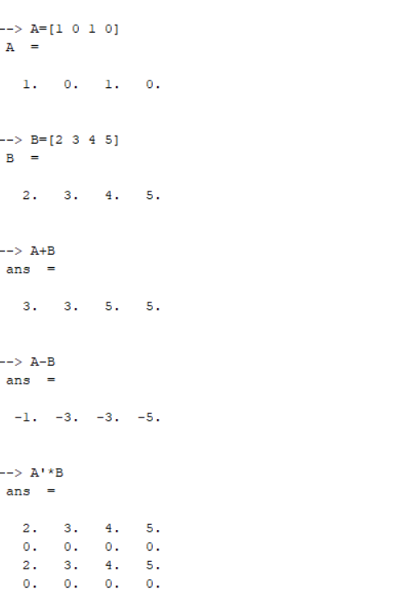

Lakshmi Narain College of Technology & Science, Bhopal

Department of Electronics and Communication Engineering

Name: Madhuri Darkar Enrolment no.:0157EC181048 Class: EC V D

Date: 25/08/20 Page no.: 11

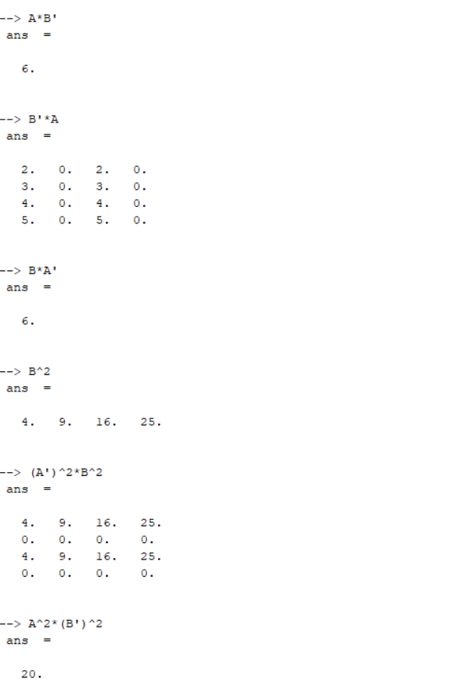

Lakshmi Narain College of Technology & Science, Bhopal

Department of Electronics and Communication Engineering

Name: Madhuri Darkar Enrolment no.:0157EC181048 Class: EC V D

Date: 25/08/20 Page no.: 12

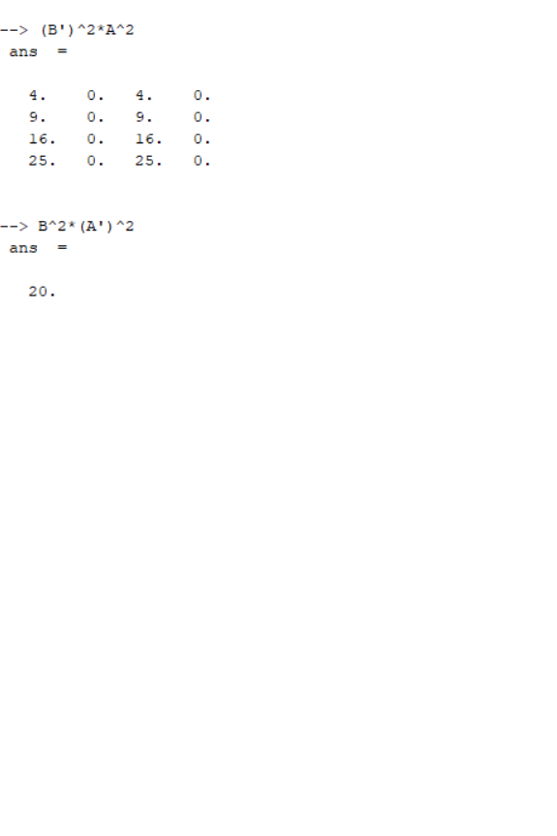

Teacher’s signature